STE Chapter 3 Assignment

1. Draw Level 0 and Level 1 DFD for : Hospital Management System, Library Management System, Online Shopping System, Hotel Management System,
Book Donation Portal.

Ans.
Hospital Management System
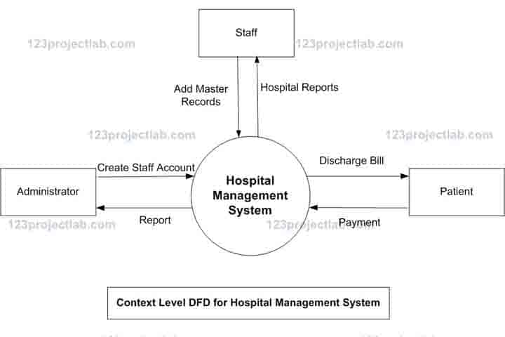
Level 0 DFD

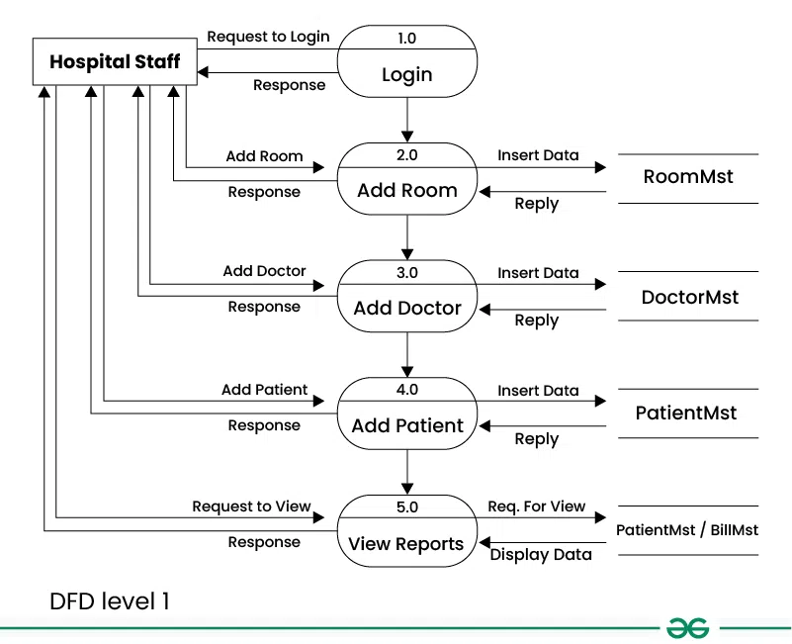
Level 1 DFD

Library Management System
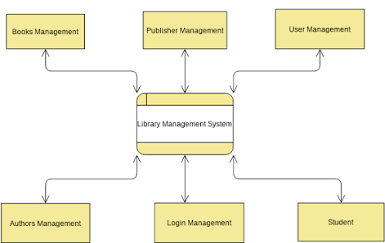
Level 0 DFD

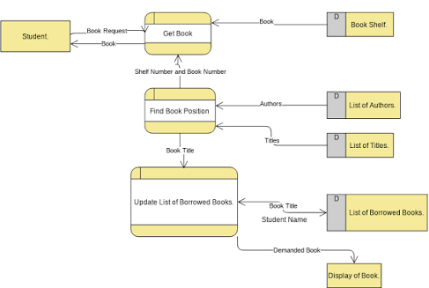
Level 1 DFD

Online Shopping System
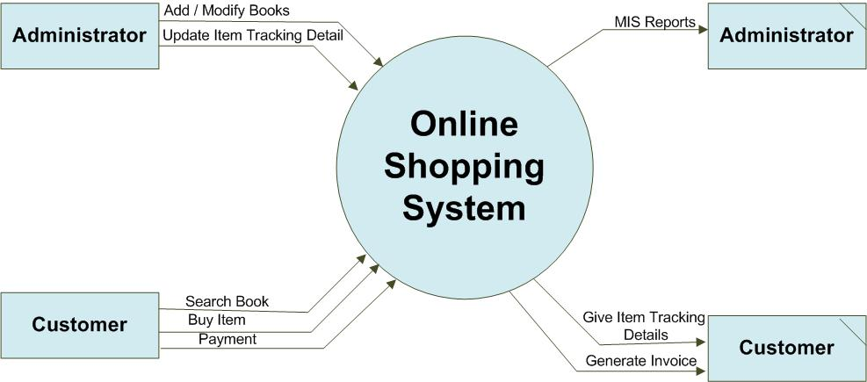
Level 0 DFD

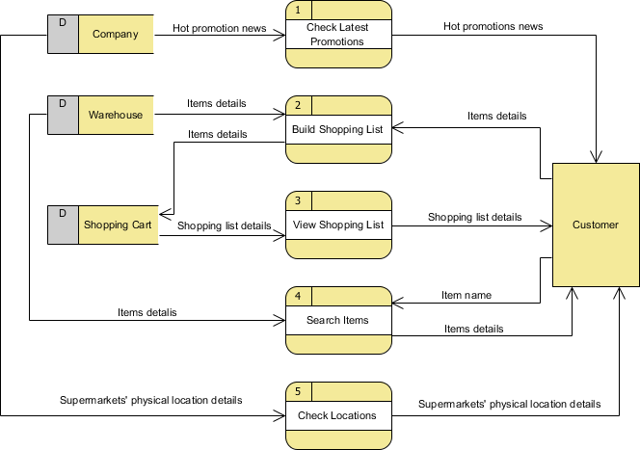
Level 1 DFD

Hotel Management System
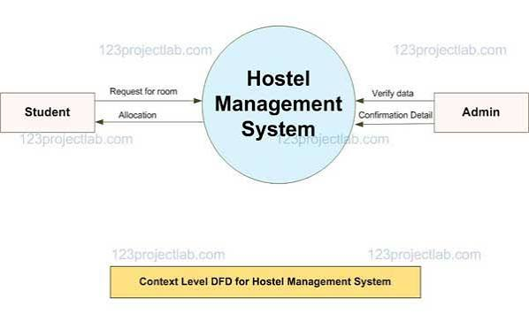
Level 0 DFD

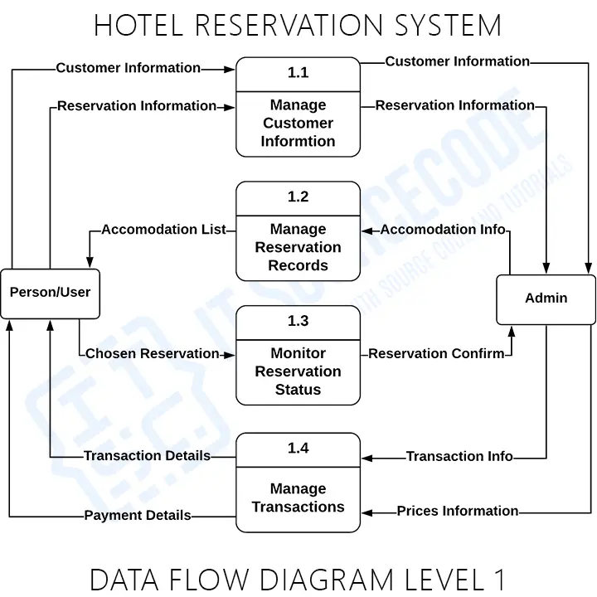
Level 1 DFD

Book Donation Portal
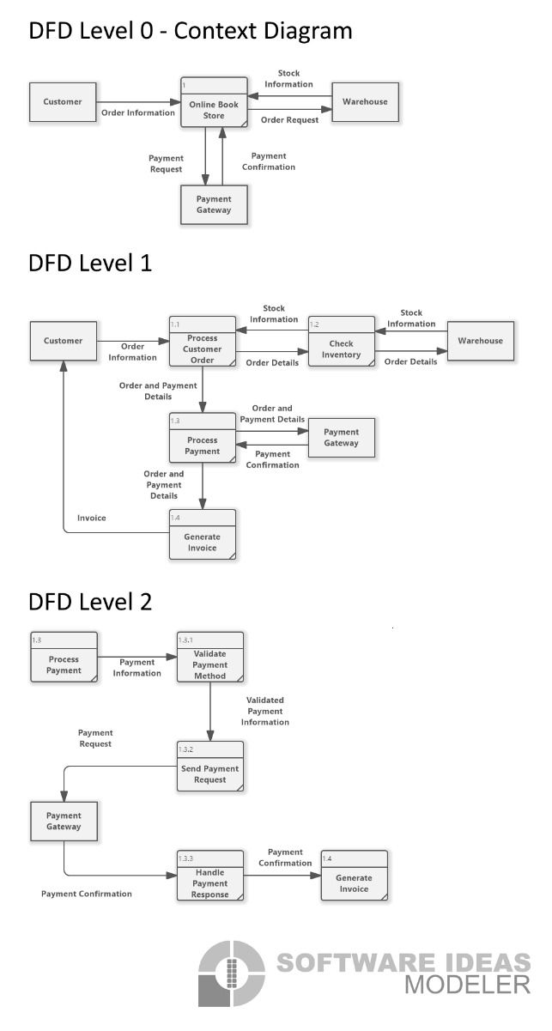
Level 0 DFD

Level 1 DFD

DFD Symbols
Symbol | Meaning
Rectangle | External entity (user, admin, doctor)
Circle | Process that transforms data
Cylinder | Data store or database
Arrow | Direction of data flow

2. Draw Use Case Diagram for : Hospital Management System, Library
Management System, Online Shopping System, Hotel Management System,
Book Donation Portal.

Ans.

Hospital Management System
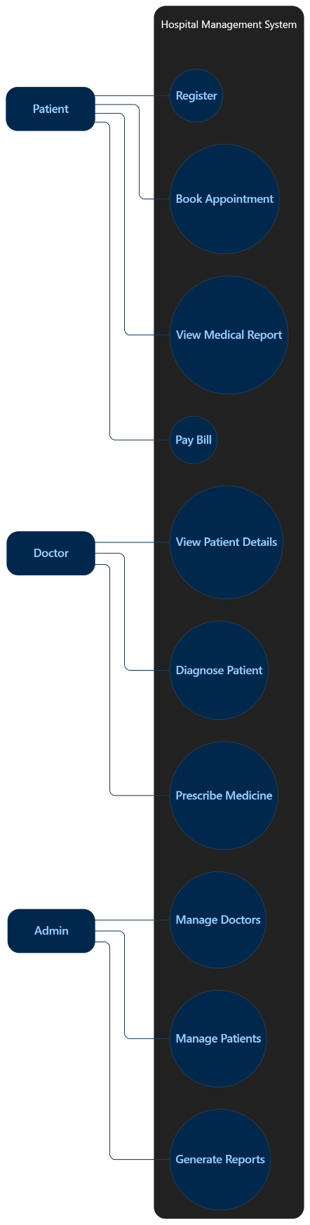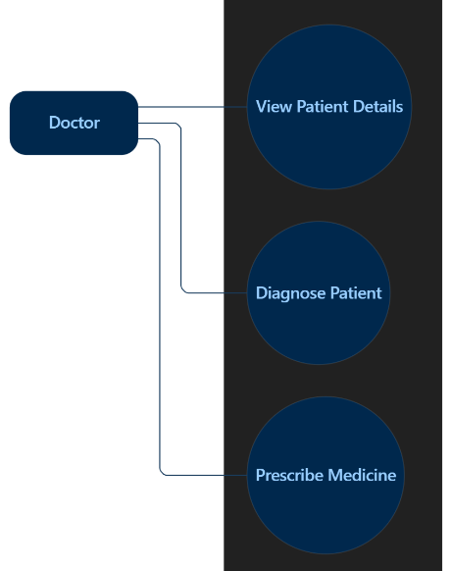

Library Management System
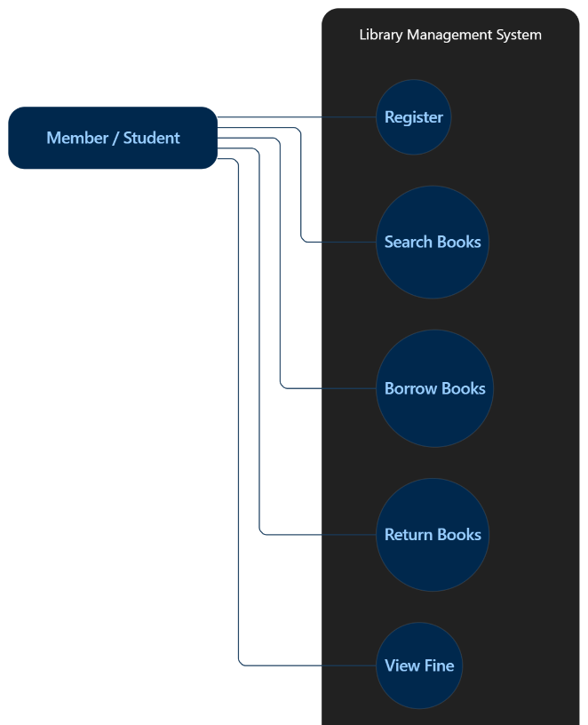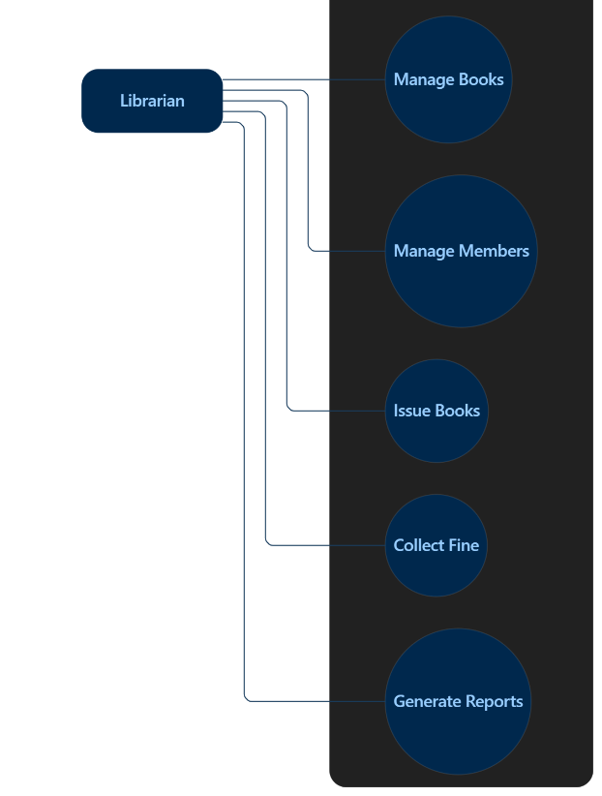

Online Shopping System
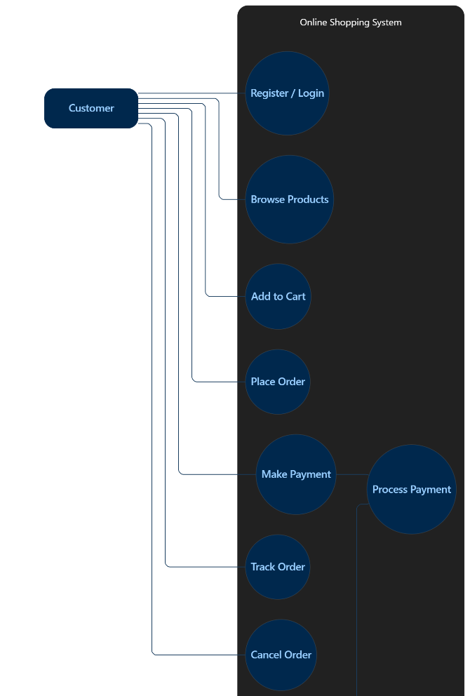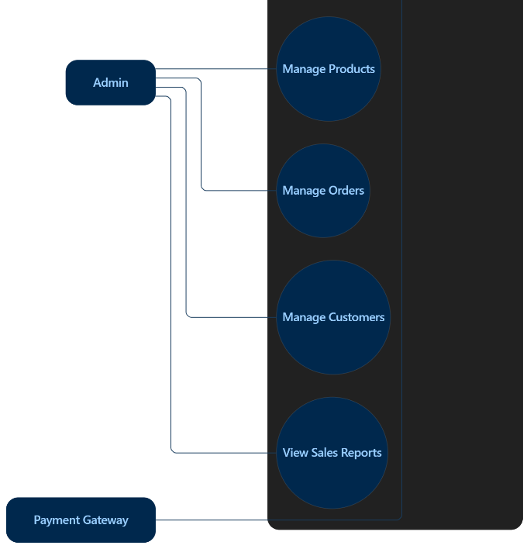

Hotel Management System
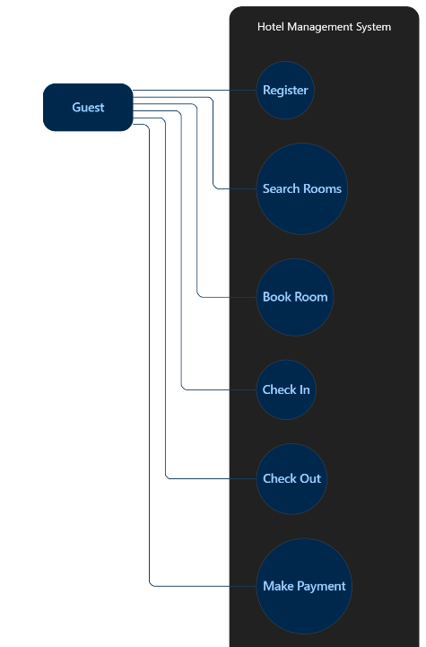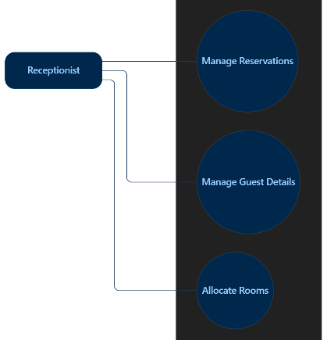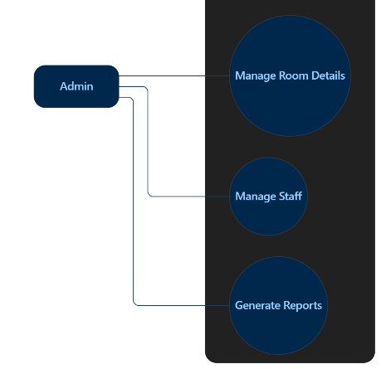

Book Donation Portal
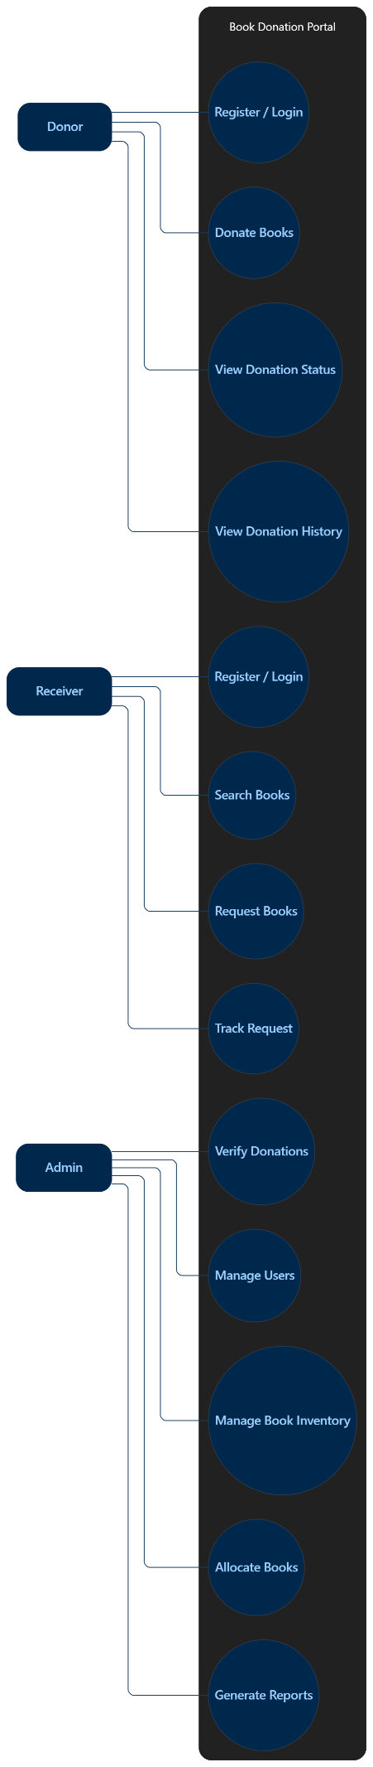

3. Draw Structured Flowchart for : Hospital Management System, Library
Management System, Online Shopping System, Hotel Management System,
Book Donation Portal.

Ans.

Hospital Management System
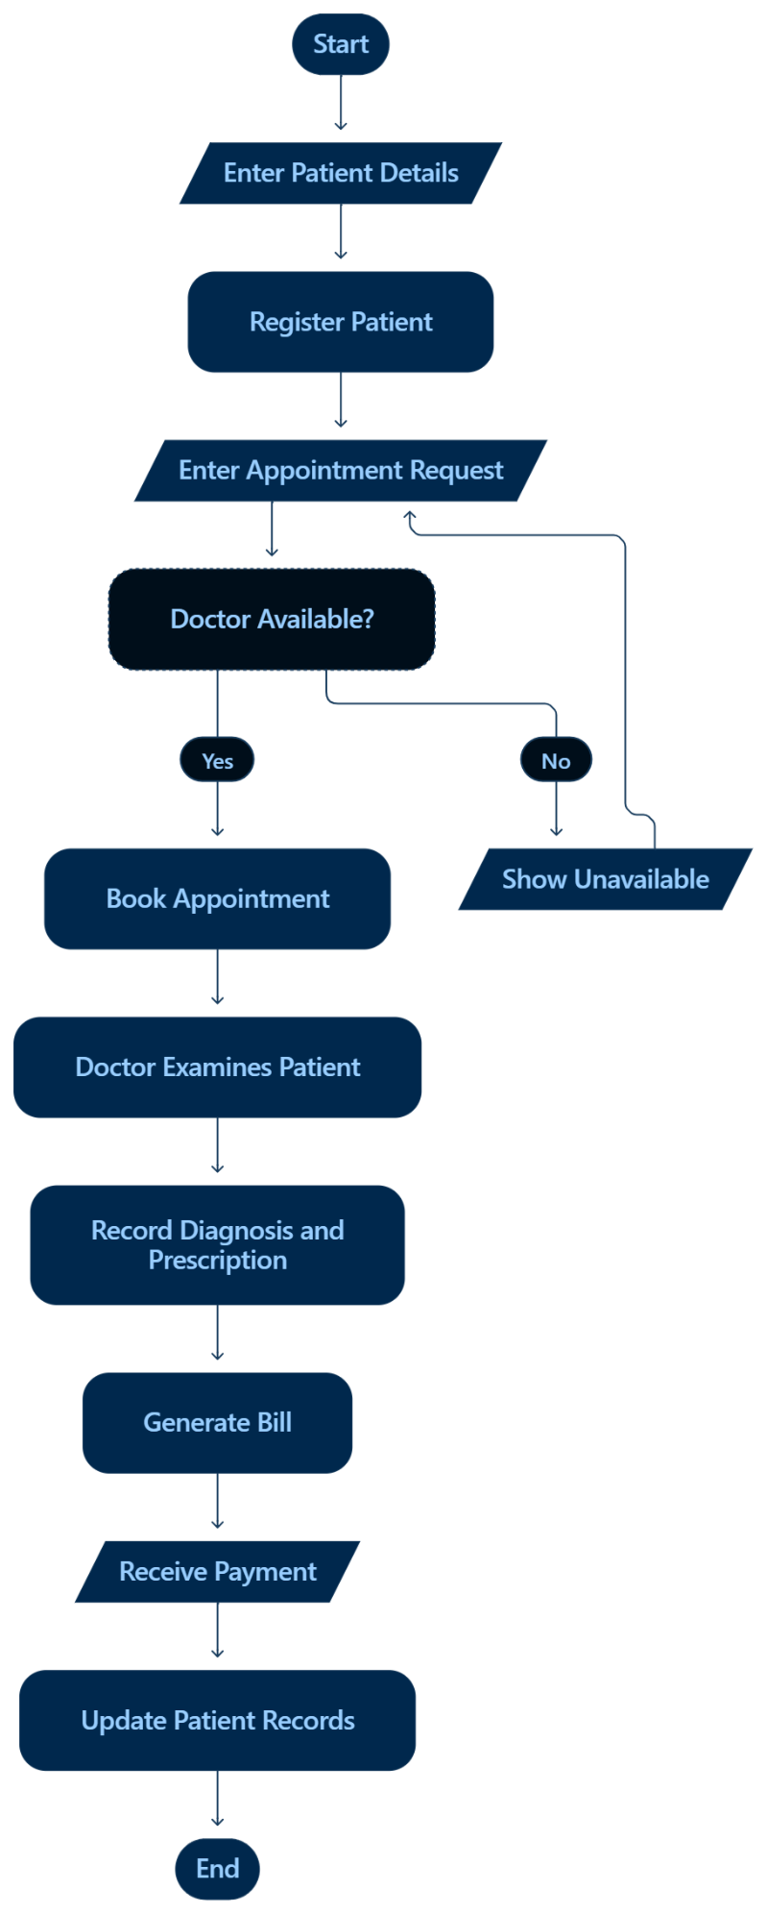

Library Management System
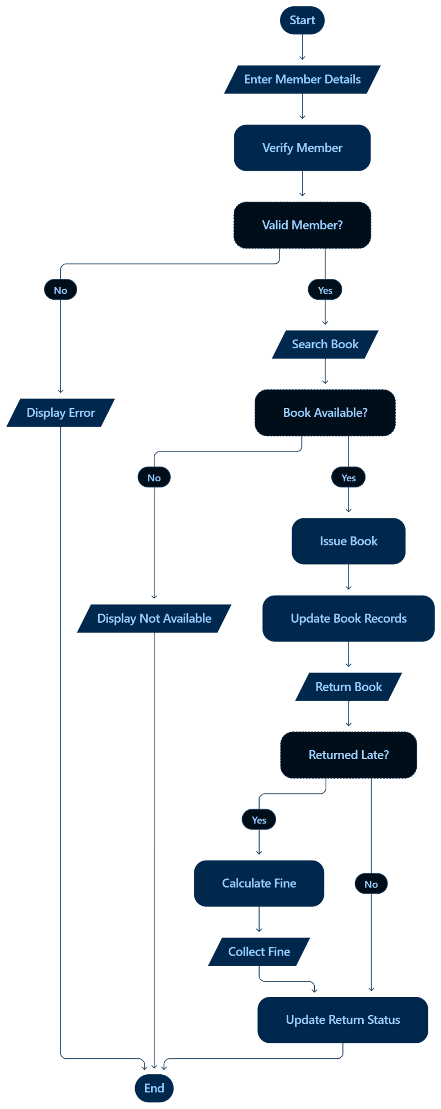

Online Shopping System
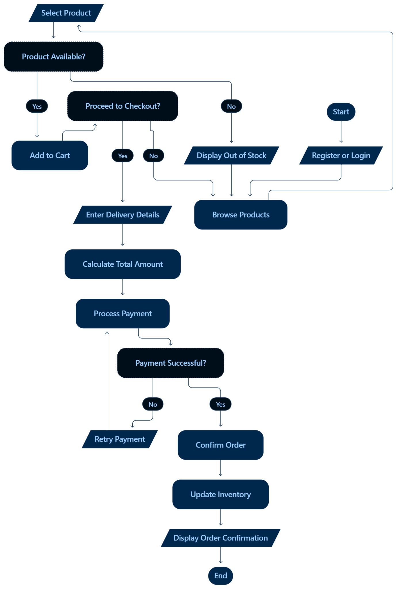
Hotel Management System
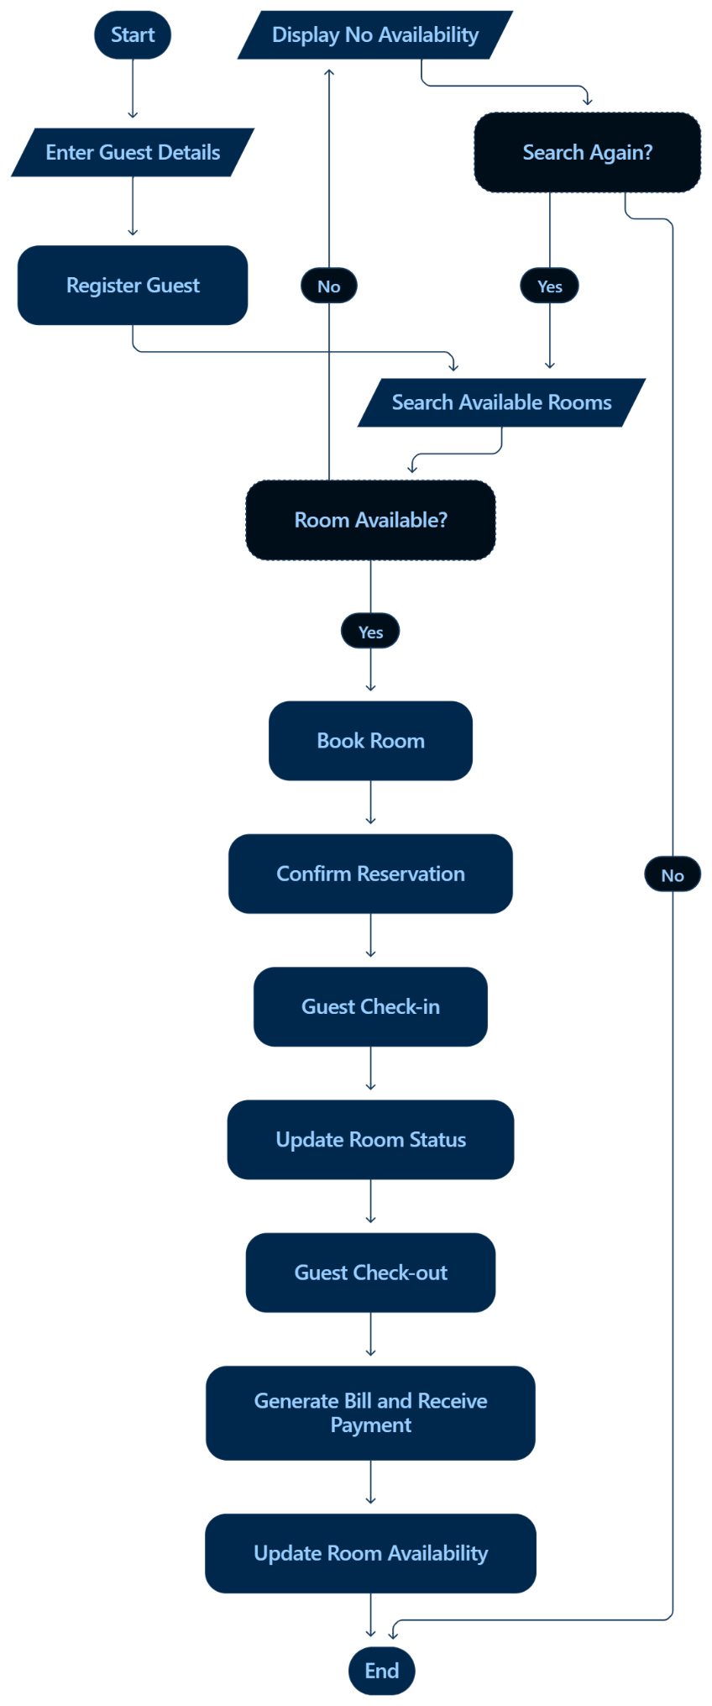
Book Donation Portal
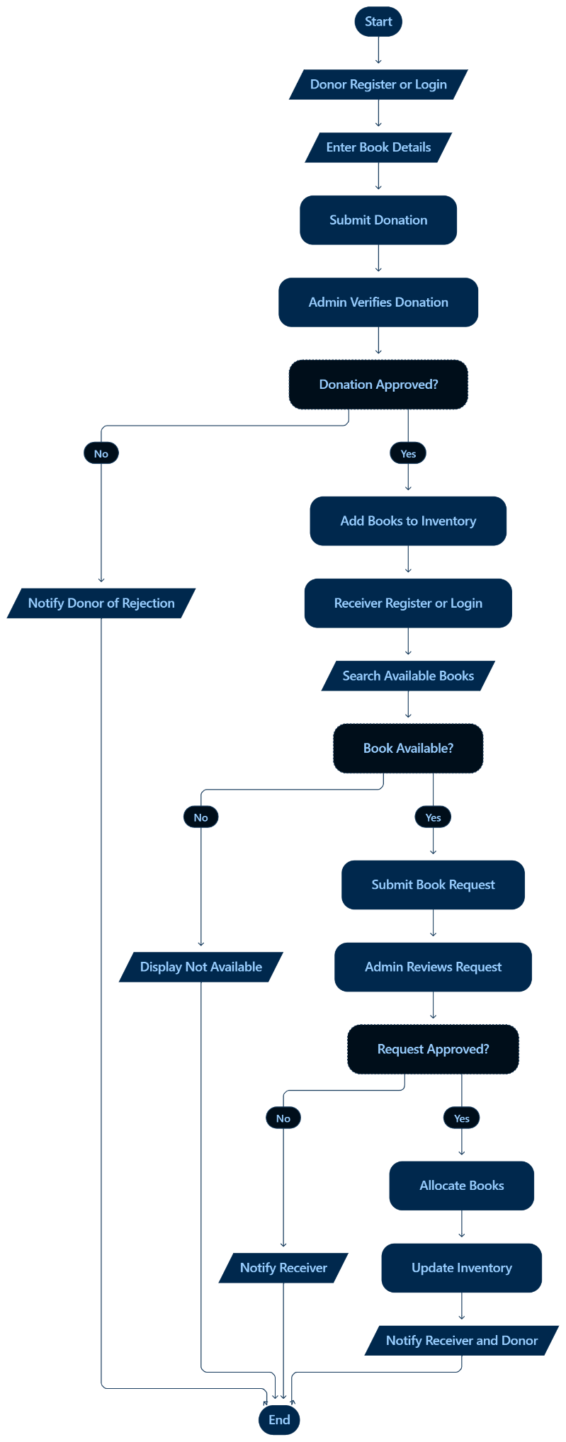
4. Differentiate between White-Box Testing and Black-Box Testing.

Ans.
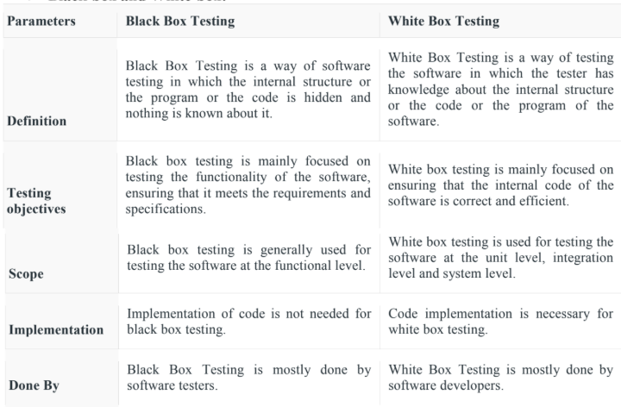
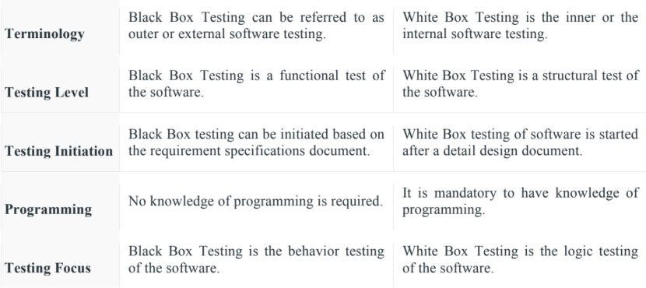

5. Draw and explain the V-Model of Software Development Life Cycle.

Ans.
1. The V-Model is a software development lifecycle (SDLC) model that extends the waterfall model by creating a V-shaped process with closely associated verification and validation phases.

2. On the left side of the "V", development stages like requirements analysis and design are performed, while on the right side, corresponding testing phases (such as unit testing, integration testing, and acceptance testing) are planned and executed in parallel, ensuring quality throughout the process.

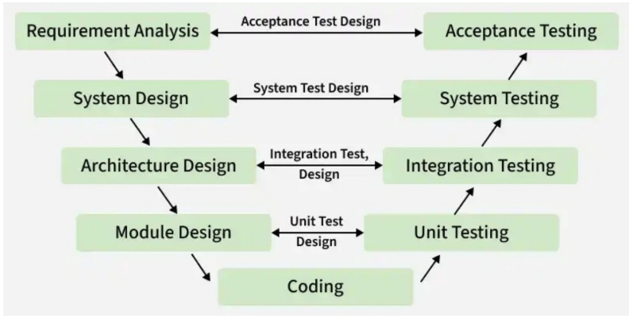

1. V-Model Verification Phases

- This is where the process begins. The first step is to gather and understand the customer’ s needs for the software. The goal is to define the scope of the project clearly to make sure everyone is on the same page.

- It involves a static analysis technique (review) done without executing code. It is the process of evaluation of the product development phase to find whether specified requirements are met.

There are several Verification phases in the V-Model : -

1. Business Requirement Analysis

- This is the first step of the designation of the development cycle where product requirement needs to be cured from the customer' s perspective. These phases include proper communication with the customer to understand their requirements.

- These are the very important activities that need to be handled properly, as most of the time customers do not know exactly what they want, and they are not sure about it at that time then we use an acceptance test design planning which is done at the time of business requirement it will be used as an input for acceptance testing.

2. System Design

- In this phase, the overall structure of the software is planned out. The team develops both the high- level design (how the system will be structured) and detailed design (how the individual components will work).

- Design of the system will start when the overall we are clear with the product requirements, and then need to design the system completely. This understanding will be at the beginning of complete under the product development process. these will be beneficial for the future execution of test cases.

3. Architectural Design

- In this stage, architectural specifications are comprehended and designed. Usually, several technical approaches are put out, and the ultimate choice is made after considering both the technical and financial viability. The system architecture is further divided into modules that each handle a distinct function. Another name for this is High-Level Design (HLD).

- At this point, the exchange of data and communication between the internal modules and external systems are well understood and defined. During this phase, integration tests can be created and documented using the information provided.

4. Module Design
This phase, known as Low-Level Design (LLD), specifies the comprehensive internal
design for every system module. Compatibility between the design and other external systems as well as other modules in the system architecture is crucial. Unit tests are a crucial component of any development process since they assist in identifying and eradicating the majority of mistakes and flaws at an early stage. Based on the internal module designs, these unit tests may now be created.

5. Coding Phase
- This is where the software is actually built. Developers write the code based on the design created in the previous phase.

- The Coding step involves writing the code for the system modules that were created during the Design phase.

- The system and architectural requirements are used to determine which programming language is most appropriate.

- The coding standards and principles are followed when performing the coding. Before the final build is checked into the repository, the code undergoes many code reviews and is optimized for optimal performance.

2. V-Model Validation Phases
It involves dynamic analysis techniques (functional, and non-functional), and testing done by executing code. Validation is the process of evaluating the software after the completion of the development phase to determine whether the software meets the customer' s expectations and requirements.

1. Unit Testing : In Unit testing, unit Test Plans are developed during the module design phase. These Unit Test Plans are executed to eliminate bugs in code or unit level.

2. Integration testing : After completion of unit testing Integration testing is performed. In integration testing, the modules are integrated and the system is tested. Integration testing is performed in the Architecture design phase. This test verifies the communication of modules among themselves.

3. System Testing : System testing tests the complete application with its functionality, inter-dependency, and communication. It tests the functional and non-functional requirements of the developed application.

4. User Acceptance Testing (UAT) : User Acceptance Testing (UAT) is performed in a user environment that resembles the production environment. UAT verifies that the delivered system meets the user ' s requirement and the system is ready for use in the real world.

